**Lambda Assignment**

**Q1 Write an application to perform basic arithmetic operations like add, subtract, multiply & divide. You need to define a functional interface first.**

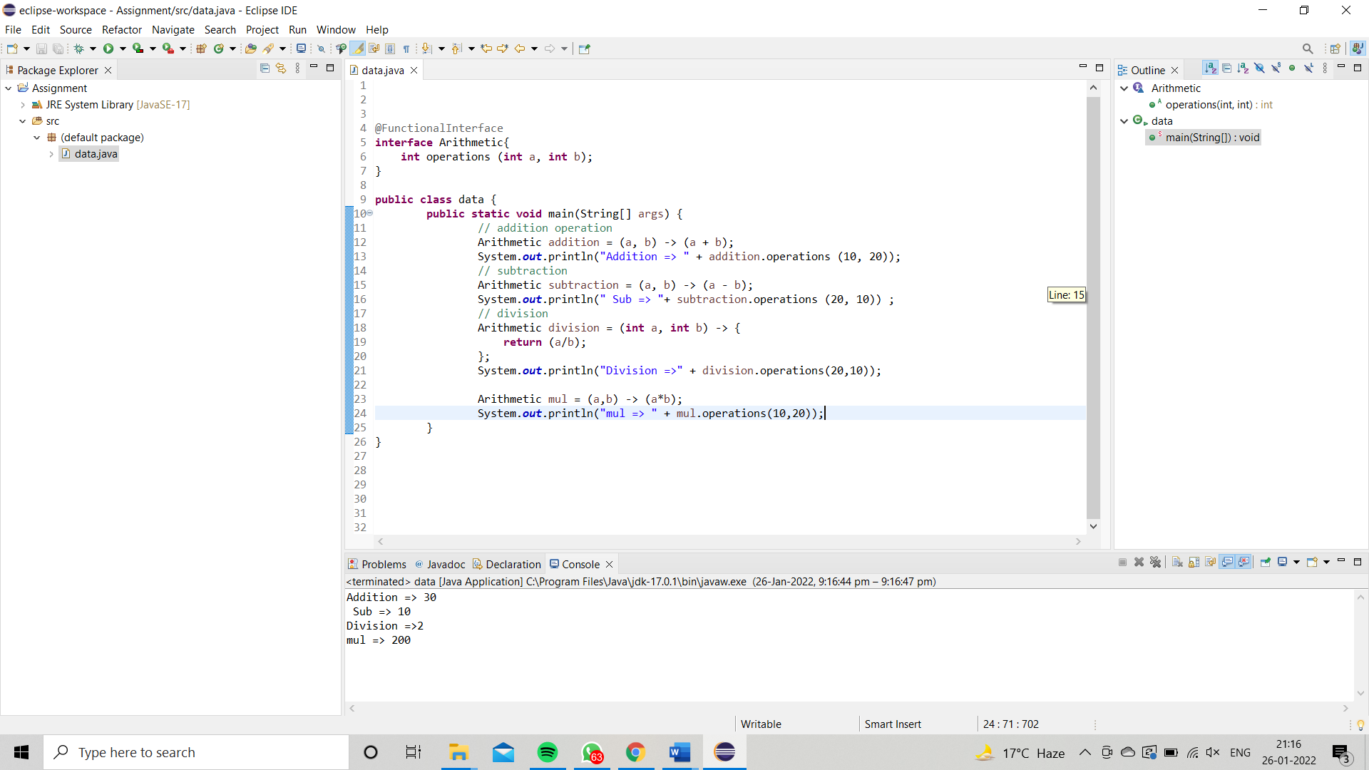

**Q2 Write an application using lambda expressions to print Orders having 2 criteria implemented: 1) order price more than 10000 2) order status is ACCEPTED or COMPLETED.**

**Q3.Use the functional interfaces Supplier, Consumer, Predicate & Function to invoke built-in methods from Java API.**

**Q4.  Remove the words that have odd lengths from the list. HINT: Use one of the new methods from JDK 8. Use removeIf() method from Collection interface.**

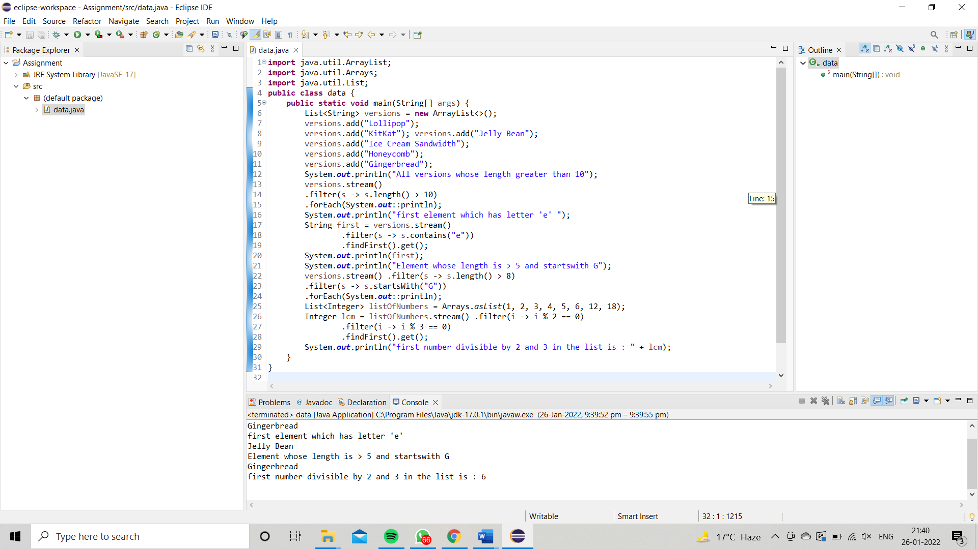

Q5. **Create a string that consists of the first letter of each word in the list of Strings provided. HINT: Use Consumer interface & a String Builder to construct the result**

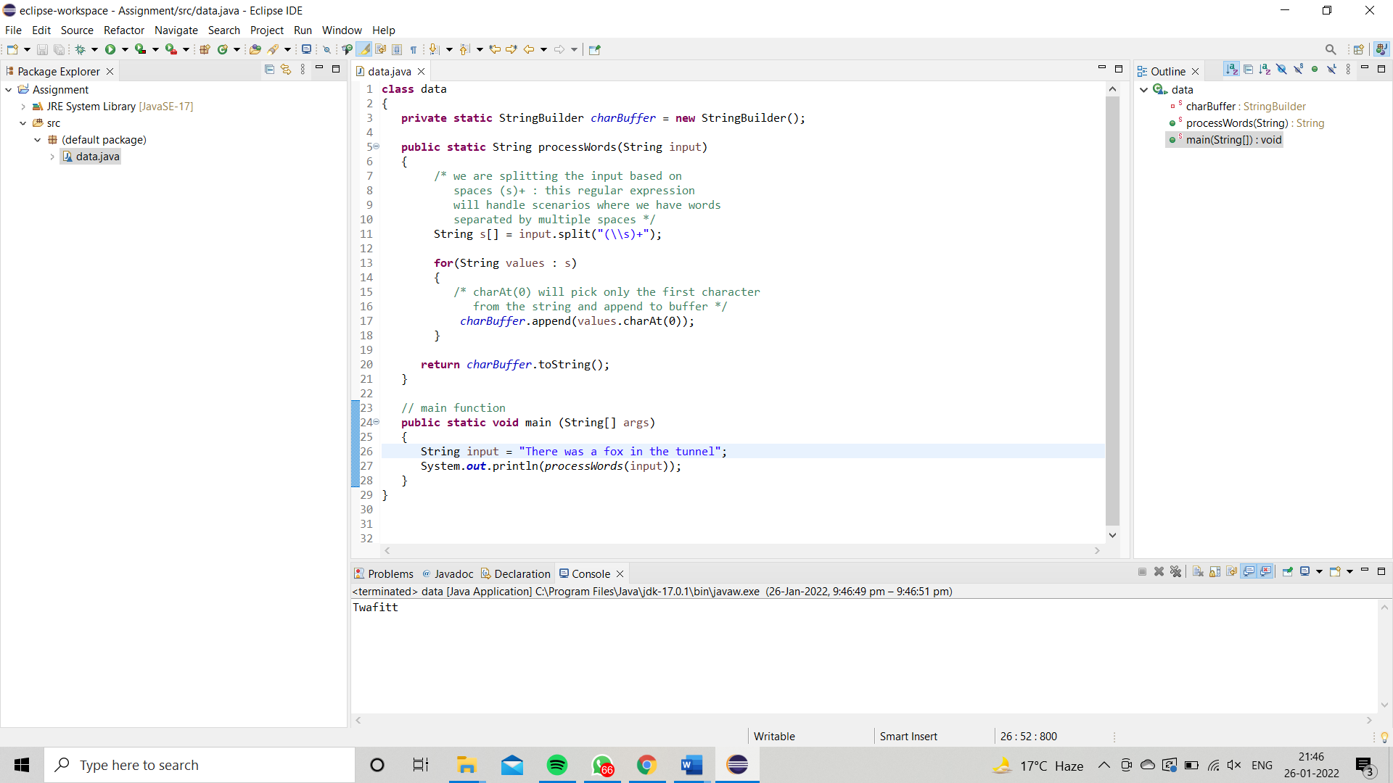

**Q6. Replace every word in the list with its upper case equivalent. Use replaceAll() method & Unary Operator interface.**

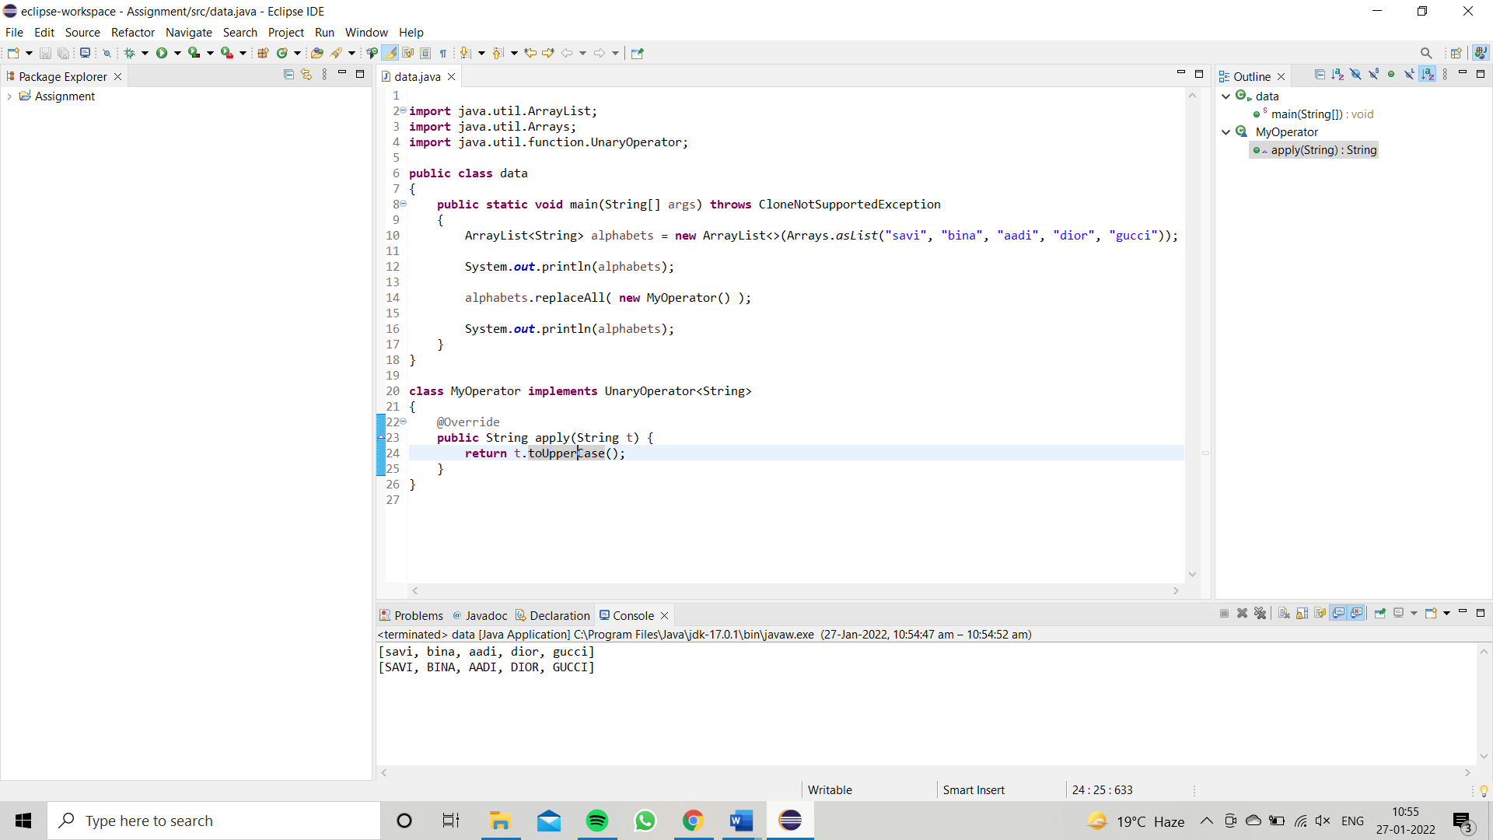

**Q7. Convert every key-value pair of the map into a string and append them all into a single string, in iteration order. HINT: Use Map.entrySet() method & a StringBuilder to construct the result String.**

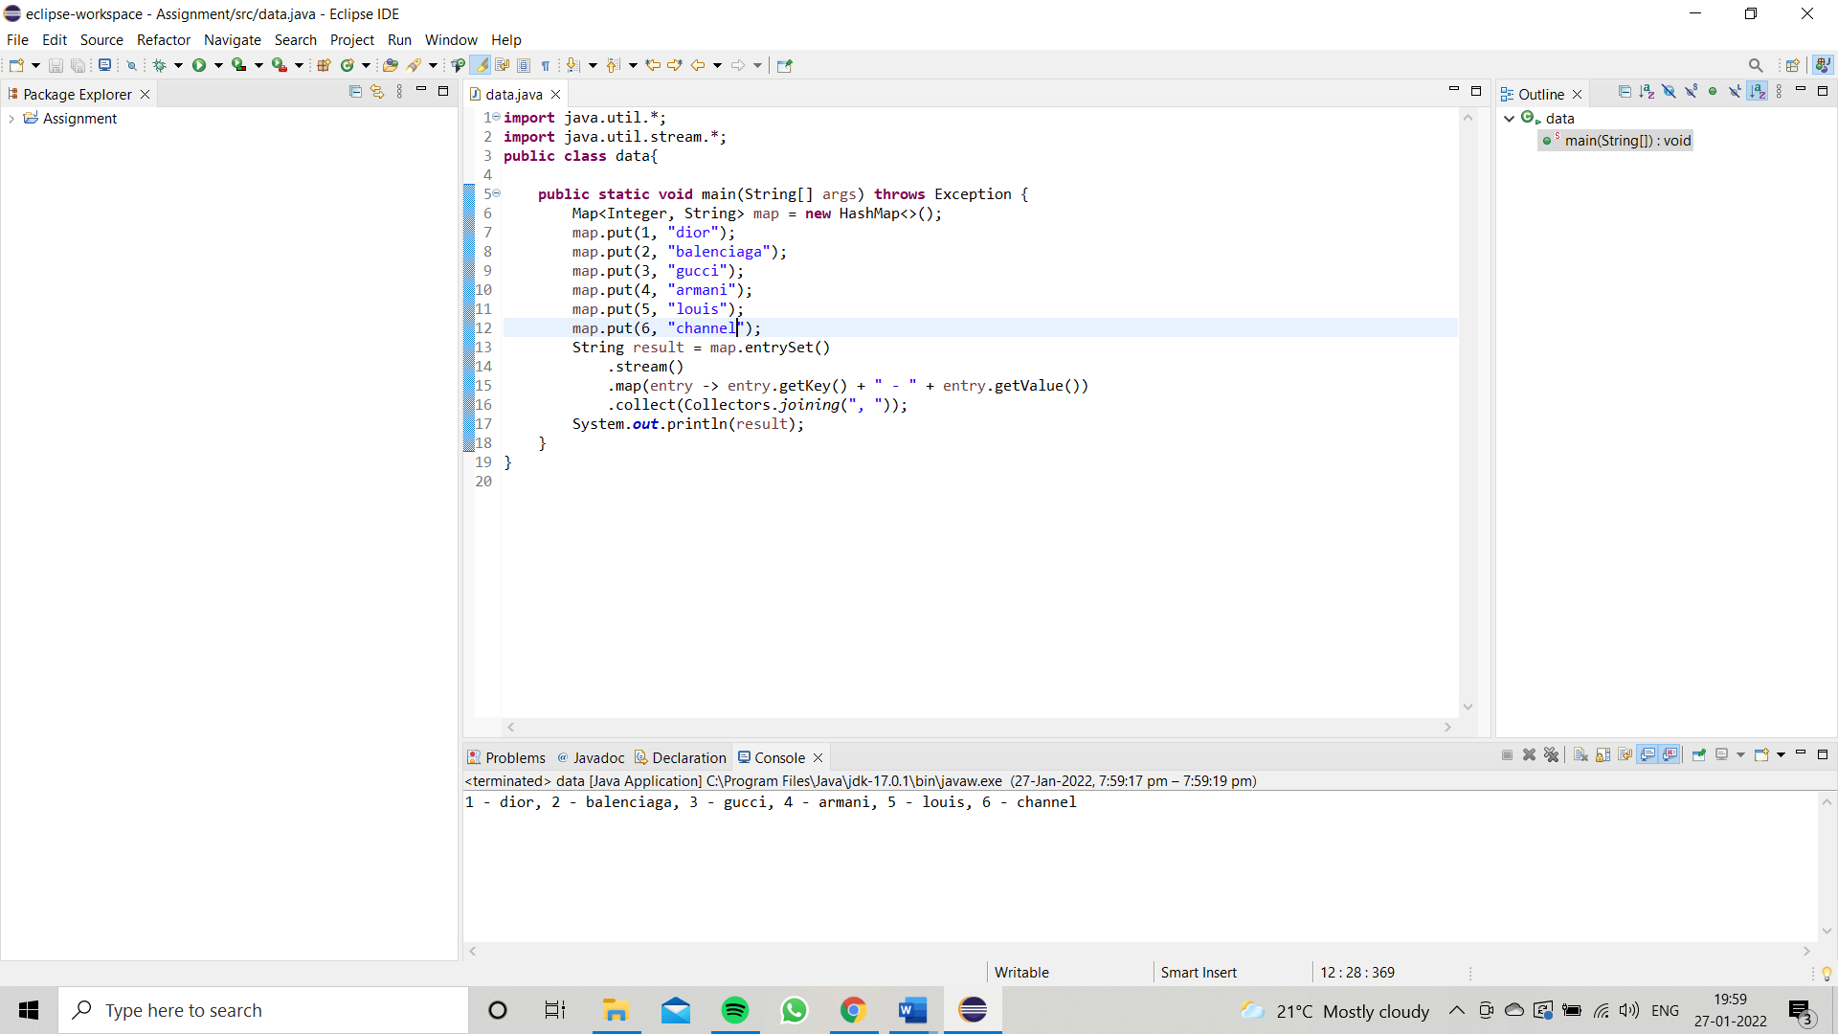

**Q8. Create a new thread that prints the numbers from the list. Use class Thread & interface Consumer.**

